**School uniform, equipment & personal presentation 2022/2023**

Families and children come to Durrington because it is an excellent school. Our school continues to be based on clear values, there is a continued expectation that our students take **pride** in the uniform they wear and how they present themselves every day.

We have taken careful steps to ensure our school uniform is as reasonably priced as possible. We have kept many of the items of uniform generic and these can be sourced at relatively low cost from a range of providers including supermarkets and via the internet.   In addition, from Autumn 2022, we will be running a half-termly recycled uniform provision where parents/carers can come in and purchase pre-owned items of uniform at significantly lower cost.  These steps ensure that the costing of uniform is accessible to all students and families.

Please see the details of the uniform and equipment expectations for all students (each and every day):

**Skirt:** The  **exclusive skirt** is a black knee-length Banner “A” line Salisbury style only. The hem of the skirt should lie / remain on the knee at all times and can be purchased from Broadwater Sports schooljumpers.co.uk and First 4 Uniform. First4uniform.com. This is the only acceptable skirt.

**Trousers:** Trousers must be straight-legged and be plain black material only, i.e. no tapering (getting thinner) or flaring (widening) towards the ankle. Trousers that are skinny fit/skin tight, denim, made of heavy cotton material, contain Lycra, or similar stretchy / elastic fabric that would cause them to look skin tight/tapered or with logos are not acceptable. Trousers should not have additional buttons / zips / sequins / rips / studs / poppers / makers' labels or names on them. Trousers should be worn to the waist and not be worn in a low-slung manner. They must also be long enough to reach the top of the shoe when standing.

**Belt:** Plain black belts only. Belt buckles should be discreet. They must not be coloured, displaying a logo or be any larger than the width of the trouser waistband.

**Shirt:** Plain white shirt with collar (not fitted, tailored or blouses). Both long- sleeved and short-sleeved are acceptable. No logos are allowed on shirts. Shirts should be worn with all buttons (including the top button) done up at all times. They must also be long enough to fully tucked into trousers/skirts.

**Tie:** Durrington High School company tie. Ties should be worn with the knot covering the collar button of the shirt and a minimum of 7 complete seahorses should be visible below the knot.

**Blazer:** Black with school badge.

**T-shirts:** Only plain white T-shirts can be worn beneath school shirts. In colder

weather we encourage students to wear plain white underlayers.

**Tights:** Plain black or neutral shades only. Leggings are not tights and should not be worn as an alternative.

**Socks:** Plain black only, with no visible branding or writing on the sock must be worn no higher than the bottom of the knee.

**Footwear:** Formal black shoes only. Sandals, backless shoes, boots, plimsolls, or black trainers are not acceptable. Sports branded footwear is not acceptable at any time as a school shoe.

**Coats:** Coats/ other jumpers/scarves are not permitted to be worn within the school building during the school day. Students are expected to be in full uniform from 8.40am each morning.

**Hair styles** Extreme styles of hair are unacceptable. Where hair is shaved in style, it should be of a grade 1 or longer. Styles such as Mohicans, Mohawks, long spiking up of hair on top of the head or similar are classed as extreme styles and not permitted. Shaved lines and/or patterns are not acceptable.

**Hair colours** Unnatural colours (for example red/plum/purple tinted), distinctly two tone/dip-dye hair are not acceptable. If you are in any doubt please contact the school **before** getting hair cut/styled. If hair is braided the braids must also be of a natural colour, this means no non-natural colours can we weaved into hair.

The school’s decision on what constitutes an extreme style, acceptable hair colouring is final. We actively encourage a discussion with us before any significant change of style is made.

**Jewellery:** For safety reasons, only one pair of small (<3mm) plain metal (silver or gold) stud earrings can be worn. No other jewellery is allowed. If worn, this will be confiscated by staff and returned at the end of the day. Nose studs/piercings and all other forms of body modification are forbidden in school.

**Badges**:            School issued badges (e.g. KAPP badges) form part of the school uniform. If/when awarded it is expected that all students will wear their badge(s) with pride, badges being worn on either lapel of their blazer. No other badges/flags or similar items are allowed to be added to any item of school uniform.

**Religious Observance:** Head coverings should be plain black.

**Personal Presentation:** Makeup should be discreet.

Nail varnish, nail polish, acrylic or false nails and/or nail art are not to be worn. All false eyelashes, including stick on / strip eyelashes and eyelash extensions are to be removed and **should not** be worn at school at any time. This in response to parental and student confirmation for clarification around this area. Themed makeup (examples being looks associated with Anime and Gothic) is not permitted. No pen or other drawing on the skin is permissible, neither are any temporary tattoos.

On the rare occasion where a student doesn’t meet basic uniform/personal presentation expectations they will be removed from lessons. Thus, we strongly encourage parents/carers and/or students to “check first” with the school before purchasing items or colouring/styling hair. The Headteachers’ decision is final.

We thank you for the support that parents/carers give in relation to our basic expectations and ensuring their child attends school and is ready to learn each and every day.

**We expect all students to wear their uniform in the following way:**

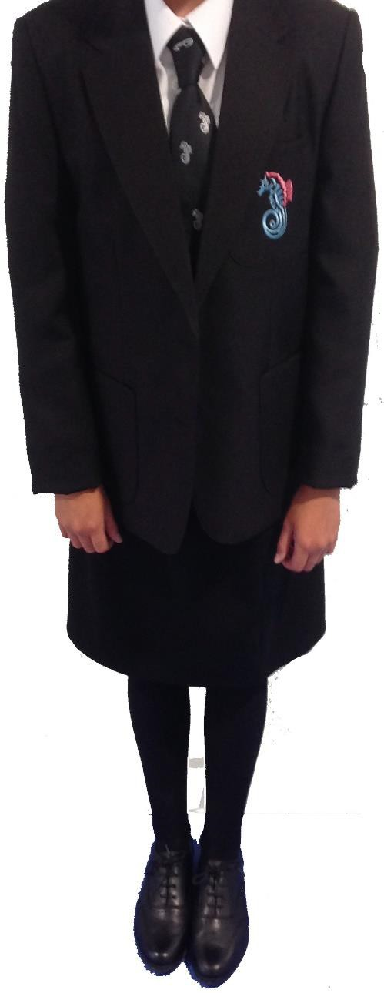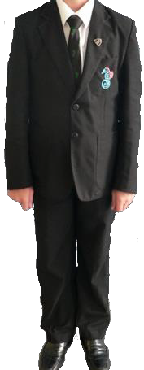

The **top button** on the shirt is done up with the knot of the **tie** covering it. Seven seahorses should be visible below the knot at all times

**Blazers** should be worn at all times in the building (in hot weather students will be informed of a change in the rule)

Items worn under shirts (T shirts etc.) are plain white with no colours, writing or logos on them.

**Shirts** are long enough to be fully tucked in to trousers/skirts. Shirts must not be fitted or have buttons missing.

**Trousers** must be straight legged and be plain black material only i.e. no tapering (getting thinner) or flaring (widening) towards the ankle.

Trousers that are skinny fit/skin tight, denim, made of heavy cotton material, contain Lycra, or similar stretchy / elastic fabric that would cause them when worn to look skin tight/tapered, or with logos are not acceptable. Neither should trousers have additional buttons /zips / sequins / rips / studs / poppers/labels or names on them.

labels or names on them.

Trousers should be worn to the waist and not be worn in a low-slung manner. Trousers must reach the top of the shoe when standing.

Skirts must be the Banner A Line style and must be to the knee at all times.

**Socks** are plain black and **shoes** are formal and plain black.

Sandals, backless shoes, boots, plimsolls, or black trainers are not acceptable.



**PE kit**

**Indoor** Sky blue polo shirt with school logo

Plain navy blue shorts only, logo to be no bigger than thumb size

White sports socks

Non-marking trainers (N.B. no skateboard shoes or flat-soled trainers) Leggings- plain black with a logo no bigger than thumb size may be worn for dance and gymnastics only. They should have no additional writing, stripes or branding on them.

**Outdoor** Navy blue reversible rugby shirt with sky blue band or

DHS PE hooded top with school logo

Plain navy blue shorts, logo no bigger than thumb size. Black shorts are not acceptable.

Plain navy blue football/rugby socks

Football boots

Plain navy blue tracksuit bottoms may be worn over shorts, for autumn –

spring term. Logo to be no bigger than thumb.

Plain navy or black base layer (Under Armour) may be worn (autumn to spring terms only)

**For information:**

In **every** PE lesson, students are required to **remove** all items of jewellery. This includes earrings and watches. Earring tape is not considered acceptable to cover piercings; the earring must be taken out. Please note that students will not be permitted to sit out of PE whilst any form of piercing heals. It is not acceptable for a student to sit out of PE because they cannot remove their earrings.

Deodorant should not be of an aerosol type.

**Equipment**

All students are required to bring the following pieces of essential school equipment on a daily basis:

* **School bag**

A practical school bag should be brought to school each day by all students. This should be big

enough to carry books, PE kit and a coat. Handbag style bags are generally unsuitable.

* **Equipment**

3Ps (pens, pencils, paperback)

A ruler, rubber, protractor and scientific calculator

Students **must not** bring in scissors or a compass, if needed in lessons these will be provided.

**Mobile Phones and other electronic devices / accessories**

At Durrington we want each student to get the most out of each and every day at school. In line with the recommendations from the Department for Education we have restricted the use of mobile phones & other electronic devices / accessories (for example portable gaming devices, music playing devices, tablets, headphones, Bluetooth speakers) on the school site. If a student is found to be communicating via a linked device this will be treated in the same way as the use of a mobile phone.

Specifically; this means that students **are** permitted to carry mobile phones / devices on their person. However, they **are not permitted** to be used or be visible at any point when they are on the school site/during the school day*. The exception to this rule would be if a you were directed by a member of staff to use a device in lesson for identified educational reasons. At all other times, all devices should be switched off (not turned on and silenced) and not visible.

*the school day is defined as the moment students enter onto site in the morning to the moment they leave and remain outside the building at 3.10pm/3pm on Fridays.

Should parents / carers need to contact a student during the school day, this should be done via the main school reception and any necessary message can be relayed to the student. Equally, if there is a need for a student to contact home, this can (where reasonable to do so) be facilitated by the company team at break or lunchtime.

*Last update: CWO 22 July 2022*