

Year 11 Handbook

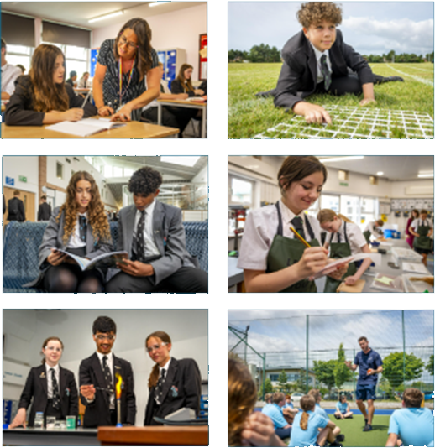

**Going Beyond Our Best** through Kindness, Aspiration, Perseverance and Pride

**CONTENTS**

Tracking you child’s academic progress 3

Subject assessment dates for TP4 3

Yr. 11 timeline: key dates and events 4

Yr. 11 timeline: printable graphic 5

Revision materials to purchase (Arbor) 6-8

Additional revision materials for every subject 9-12

Parent and carer mock support evening 2nd Nov 13

In school Revision provision (P7 and morning revision schedule) 14

How to revise effectively? 16

**Tracking your child’s academic progress**

We have three key tracking points throughout year 11. Tracking point 4 in oct, Tracking point 5 (their mock exams) in Nov/Dec and Tracking point 6 April. During these cycles your child will be expected to revise key topics and practice exam strategies at home. Please find a list of available revision material and resources for all subject areas below and on our website.

Your child will then sit a series of exams in all of their subjects, these will take place in the weeks prior to the tracking point. Tracking points provide the class teacher with key information regarding where your child is currently working, this information will be shared with you and your child. The information from tracking points is also used to amend curriculums to ensure they are designed to give your child the best possible chance to achieve excellent outcomes at the end of their GCSE journey. Please see the table below which outlines the next tracking point (TP4) information for each subject.

**Subject assessment dates for Tracking point 4 (sent home 20th Oct)**

|  |  |
| --- | --- |
| **Subject** | **11TP4 Subject Assessment dates** |
| **English Lang** | 1st part: 18/9 2nd part: 2/10 |
| **Maths** | 1st paper WC: 25/09 2nd paper WC: 02/10 |
| **Science** | w/c. 02/10/23 |
| **Chemistry** | w/c. 02/10/23 |
| **Biology** | w/c. 02/10/23 |
| **Physics** | w/c. 02/10/23 |
| **History** | 02/10/23 |
| **Computer Science** | 9/10/23 |
| **DT** | 9/10/23 |
| **Business** | 9/10/23 |
| **Media** | Ongoing assessment of coursework |
| **Art** | Ongoing assessment of portfolio work |
| **Graphics** | Ongoing assessment of portfolio work |
| **Photography** | Ongoing assessment of portfolio work |
| **Textiles** | Ongoing assessment of portfolio work |
| **Citizenship** | 2/10/23 |
| **French** | 9/10/23 |
| **Spanish** | 9/10/23 |

**Year 11 Key dates**

|  |  |  |
| --- | --- | --- |
| **Date** | **Event** | **Information** |
| **Thursday 21st Sept** | Yr. 11 Careers Evening | Information sent by Careers team 6-8pm |
| **Friday 22nd Sept** | P1: Reflections on Yr. 10 tracking point 3 (yr. 10 mocks) | Students will be given their updated TP3 yr. 10 mock results to reflect on. |
| **Monday 25th Sept** | P7 and morning revision commences | More information below |
| **Thursday 19th** | Yr. 11 Celebration evening 6pm | Invitations will follow |
| **W/C 16th Oct** | Lead up to mock examination provision | Students will get their mock timetables and revision timetables to support. |
| **Friday 20th Oct** | Tracking point 4 sent home | Report sent home and given to students. This will show their current grade and projected grade for each subject. |
| **Thursday 2nd Nov** | Parent/carer -Mock support evening 5.50-6.60 pm | More information below on how to reserve your place |
| **W/C 13th Nov** | Art practical exams commence | Schedule to follow |
| **W/C 20th Nov** | French and Spanish speaking exams commence | A schedule will be sent nearer the time by the MFL team |
| **W/C 27th Nov** | Mock written examinations commence | Timetable will be sent w/c 16th Oct |
| **Tuesday January 16th** | 11TP5 (mock results) sent home  Yr. 11 assembly and photograph | Students will be given their mock results directly after assembly. |
| **Monday 13th May** | Main GCSE exams start | More information to follow |
| **Thursday 27th June** | Yr. 11 leavers assembly and summer Ball | More information to follow |
| **Thursday 22nd August** | GCSE collect day | More information to follow |

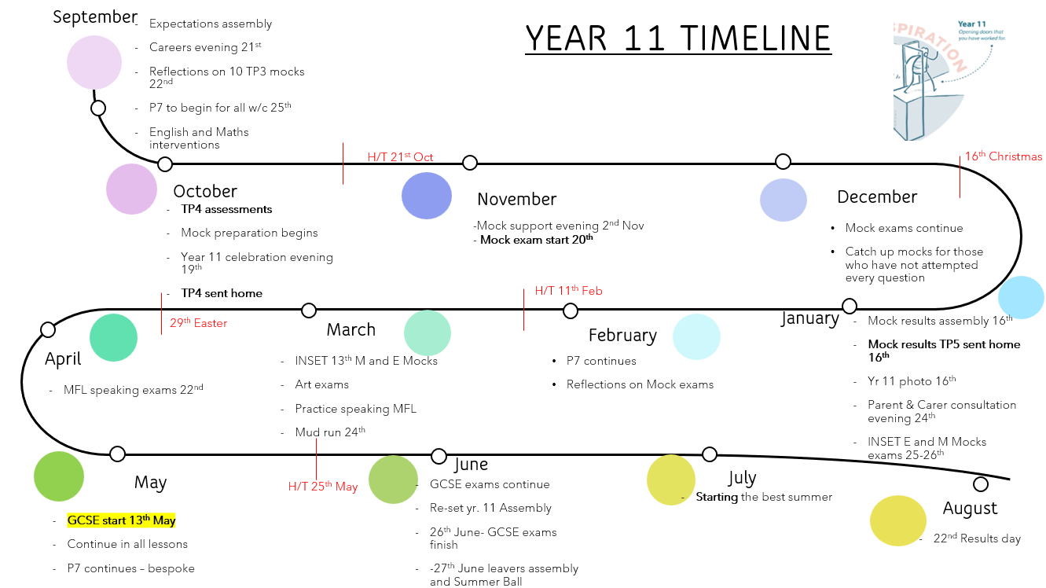

**Revision materials to purchase**

|  |  |  |  |
| --- | --- | --- | --- |
| **Subject** | **Resource** | **Cost** | **Where to buy from** |
| **Maths** | GCSE Maths Revision Guide and Workbook  Further Maths GCSE Revision Guide and Workbook | **£8.00**  **£8.00** | **Arbor** |
| **English** | English Literature revision guides CGP     * An Inspector calls * A Christmas Carol * Macbeth * Poetry Anthology   You can also purchase a copy of Macbeth | **£12.00 all** | **Arbor** |
| **Science** | **CGP AQA Combined Science revision guide:**  CGP GCSE Combined Science AQA Revision Guide Higher Tier  CGP GCSE Combined Science AQA Revision Guide Foundation Tier  **CGP Triple Science revision guides:**  Biology: CGP GCSE Biology AQA Revision Guide  Chemistry: CGP GCSE Chemistry AQA Revision Guide  Physics: CGP GCSE Physics AQA Revision Guide | **£6.15**    **£3.20 each**  **£9.60 all three** | **Arbor** |
| **Work books**  Combined Science:  GCSE Combined Science AQA Exam Practice Workbook Higher  GCSE Combined Science AQA Exam Practice Workbook Foundation  **Triple Science:**  GCSE Biology AQA Exam Practice Workbook - Higher  GCSE Chemistry AQA Exam Practice Workbook - Higher  GCSE Physics AQA Exam Practice Workbook - Higher | **£7.00**  **£4.40 each**  **£13.20 (all three)** |
| **History** | **Pearson Edexcel revision guides:**     * History- Crime and punishment (Yr10 &11) * History- Superpower relations and the cold war (Yr. 11 only) * History- Anglo-Saxon and Norman England (Yr11 only) * History- Weimar and Nazi Germany (Yr10&11) | **£12.20 total** | **Arbor** |
| **Geography** | PG Online Clear Revise AQA Geography 8035 | **£4.80** | **Arbor**  **Collect from Mr Atkins** |
| **French and Spanish** | * Pearson Edexcel GCSE 9 - 1 French Revision Guide * Pearson Edexcel GCSE 9 – 1 French Workbook * Pearson Edexcel GCSE 9 - 1 Spanish Revision Guide * Pearson Edexcel GCSE 9 – 1 Spanish Workbook | **£3 each** | **Arbor** |
| **Physical Education** | Pearson AQA GCSE PE Revision guides | **£2.65** | **Arbor** |
| **Business** | Pearson Edexcel GCSE (9-1) Business revision guides  Pearson Edexcel GCSE (9-1) Business workbook | **£5.99**  **£5.99** | **Arbor**  **amazon** |
| **Computer Science** | GCSE OCR Computer Science Workbook and revision guide | **£6.10** | **Arbor** |
| **BTEC I.T** | Revision guide | **£2.00** | **Arbor** |
| **Citizenship** | Pearson Edexcel GCSE Citizenship (1-9) Revision guide and Workbook | **£5.05** | **Arbor** |
| **Music and Drama** | Music: resources supplied by the department  Drama: resources provided by department | **No charge** | **Mrs Isham** |

**Additional Revision material for each subject online**

|  |  |
| --- | --- |
| **Subject** | **Resource** |
| **Maths** | Useful websites that are free to use:   * **SparxMaths.uk**: Log in and use the “independent learning” option to revise topics you are weak at. Alternatively, use the “target” and “xp boost” sections once per week to practise skills recently visited in class. * **MethodMaths.com**: Online past GCSE papers that mark answers as you go! They also give help for some questions in the form of hints. The centre ID is “durring”, and each student can get their username and password from their maths teacher. * **MathsGenie.co.uk**: Focus on specific grades or topics. Includes help videos, exam questions and worked solutions. * **CorbettMaths.com**: Videos, worksheets and practice papers. The 5-a-day section is particularly useful. * **MMERevise.co.uk**: Click Revise > GCSE Maths. Under the AQA section there are lots of exam resources including past papers with model solutions. |
| **English** | * Poetry anthology videos: <https://www.youtube.com/@mrtharbyenglish/videos> * English Language and Literature revision resources, including quote lists, knowledge organisers and exam guidance: <https://drive.google.com/drive/folders/1PRrq1XAZnaq_ZTM71EGq_AKE0l_jK8wA> |
| **Science** | * **Arbor:** Resources including practice questions, PowerPoints and knowledge organisers are available centrally from your class teacher. * **Google Classroom:** Loom videos for every part of Biology, Chemistry and Physics content are available and uploaded for you to work through. These include pause points for you to complete a practice question or a task set by the teacher. * **Practice Question Booklets**: Handed to you individually in after the October Half-Term, with an individual book for each exam paper and each subject. These are for both Triple and Trilogy science students. * **FreeScienceLessons on YouTube:** All of the GCSE Science content broken down into bitesize 2-5 minute videos. These work for both Triple and Trilogy students. <https://www.youtube.com/c/freesciencelessons> * **Dr Kyle Explains on YouTube/TikTok:** Dr Kyle has made short videos that focus on key areas of content and exam skills to help you have the best chances of success in your exams. <https://www.youtube.com/channel/UCjK0b5wr4MUeYN_UsSqsZWQ> |
| **History** | BBC Bitesize have fantastic revision resources available for some topics- including podcasts, videos and quizzes   * Germany- <https://www.bbc.co.uk/bitesize/guides/z9y64j6/revision/1> * Crime and Punishment- <https://www.bbc.co.uk/bitesize/guides/zk6k96f/revision/1> * Cold War- <https://www.bbc.co.uk/bitesize/guides/z3h9mnb/revision/1> * Normans- <https://www.bbc.co.uk/bitesize/topics/zgdk4j6>   Additionally there are a few useful youtube channels that break down the specific elements of the course   * This channel covers Crime and Punishment, Germany and the Norman Conquest - <https://www.youtube.com/@Alonglongtimeago> * Norman conquest- <https://www.youtube.com/watch?v=1sK4JX0co8I> |
| **Geography** | As the case studies studied in geography do not always match the revision guides available, the geography department advocate using their YouTube channel. This channel will also have a series of video lesson that cover the most challenging concepts students encounter in GCSE Geography which they can watch in their own time when revising.  (<https://www.youtube.com/channel/UCXVDBhNZaOUmRTGnIJHD2pQ?safe=true>) |
| **French** | * GCSE French revision resources (including speaking booklets, vocabulary booklets, knowledge organisers) in: <https://drive.google.com/drive/folders/11Q3dpk-qQvxOxq9jXdVdCk9ai8VDK9AW?usp=drive_link> * Revision flashcards on: [www.quizlet.co.uk](http://www.quizlet.co.uk) * BBC Bitesize resources for Edexcel GCSE French: <https://www.bbc.co.uk/bitesize/examspecs/zhy647h> * Past papers on Edexcel website (GCSE French 2016 specification): <https://qualifications.pearson.com/en/qualifications/edexcel-gcses/french-2016.coursematerials.html#filterQuery=Pearson-UK:Category%2FExam-materials> |
| **Spanish** | * GCSE Spanish revision resources (including speaking booklets, vocabulary booklets, knowledge organisers) in: <https://drive.google.com/drive/folders/1f9XqELCGT9UXpnA7ZXm5g9vS-hu6uz1o?usp=drive_link> * Revision flashcards on: [www.quizlet.co.uk](http://www.quizlet.co.uk) * BBC Bitesize resources for Edexcel GCSE Spanish: <https://www.bbc.co.uk/bitesize/examspecs/z799hbk> * Past papers on Edexcel website (GCSE Spanish 2016 specification): <https://qualifications.pearson.com/en/qualifications/edexcel-gcses/spanish-2016.coursematerials.html#%2FfilterQuery=category:Pearson-UK:Category%2FExam-materials> |
| **AQA Design & Technology** | * Google drive: <https://drive.google.com/drive/folders/1WDVqJ3nuZMcchN3zKdBIUJoVFwj0vkZ4?usp=sharing> * Knowledge organisers (Arbor & Google classroom) * Student class workbooks * Revision topic list (handed out by teacher, on Google classroom & Arbor) * **Revision Guides:**   <https://www.pgonline.co.uk/resources/design-and-technology/gcse-aqa/clearrevise-8552/>   * **Website:** <https://www.bbc.co.uk/bitesize/examspecs/zby2bdm> |
| **PE** | * Knowledge organisers - (Google Classroom or through school website) * <https://www.bbc.co.uk/bitesize/examspecs/zp49cwx> |
| **BTEC I.T** | * Knowledge organisers ( Google classroom) * Revision topic list (handed out by teacher, on Google classroom & Arbor) |
| **Business** | * Knowledge organisers ( Google classroom) * Student class workbooks * Revision topic list (handed out by teacher, on Google classroom & Arbor) * Past Papers and sample case studies on google classroom * **Website** <https://www.bbc.co.uk/bitesize/subjects/zpsvr82> * **YouTube:**  @TwoTeachers |
| **Computer Science** | * Knowledge organisers ( Google classroom) * All exercise books are digital and on Google classroom * Revision topic list (handed out by teacher, on Google classroom & Arbor) * SMART REVISE - this is a a paid revision resource that the school has purchased   + students all have a log in   + they have flash cards, quizzes and past exam questions on here to work through * **Website**   <https://www.bbc.co.uk/bitesize/subjects/z34k7ty>  <https://isaaccomputerscience.org/?examBoard=all&stage=all>   * **YouTube:**   + @crashcourse   + @craigndave |
| **Media Studies** | Component 1 factsheets: <https://drive.google.com/drive/folders/1ax-WChuzMTN4pGIRIZqhHhr-Duh1MAMJ>  Component 2 factsheets: <https://drive.google.com/drive/folders/1ax-WChuzMTN4pGIRIZqhHhr-Duh1MAMJ>  Video links for ALL set texts: <https://drive.google.com/drive/folders/1ax-WChuzMTN4pGIRIZqhHhr-Duh1MAMJ> |
| **AQA Food Preparation & Nutrition** | * Knowledge organisers (Arbor & Google classroom) * **Online Illuminate textbook:** Username - sdurring3 Password- student3 * Workbooks * Revision topic list (handed out by teacher, on Google classroom & Arbor) * **Revision Guides:**   <https://www.pgonline.co.uk/resources/design-and-technology/gcse-aqa/clearrevise-8585/> |

**How can you make sure you are in the best position to support your child?**

**Year 11 Parent / Carer Mock Exam Support Evening - Thursday 2 November**

A key element of preparing our year 11 students for their GCSE examinations in the summer, is the mock examinations. As well as preparing students for the process of an extensive examination period, they also give students and staff a clear picture about the progress they are making in each of their subjects.

In order to help parents and carers support our students leading up to and during this mock examination period, we will be running a ‘Parent / Carer Mock Support Evening’, on Thursday 2nd November. This will start at 5.30pm in the main hall. During the evening we will go through the process of mock examinations, the support available within school and how parents / carers can support students at home. Much of the input will focus on how students can effectively revise for these examinations so students are welcome to attend as well.

Please be aware this evening is not an opportunity to discuss individual progress of students.

**To reserve a palace at this event please use the link below:**

<https://forms.gle/LVqxMaod3ERhHdnCA>

**Extra revision opportunities with subject specialists: Period 7 and morning sessions**

Our P7 and morning revision provision is another opportunity for your child to practice and embed key content and skills with a subject specialist. These sessions will be a mix of master classes (where all students are invited to attend) and tutorials (where selected students will be invited to attend).

Students will be given a copy of the timetable during P1 where they will be able to plan which sessions they will attend. If students have been specifically invited to attend a tutorial you and your child will be informed. We expect all our students to access the excellent P7 provision that our staff have laid on for them. Students that typically start the revision process earlier not only excel in the GCSEs, but show more resilience to the challenges of the year.

Please see a copy of the timetable below, it will also appear on your child’s Arbor timetable.

|  |  |  |
| --- | --- | --- |
| **Day** | **Morning**  **8-8.30 am** | **After school**  **3.15-4.15 (unless stated otherwise)** |
| **Monday** | **Science:**  TWa - G16 - Biology  GFi - L1 - Biology  ABr - L2 - Physics | **Week A:**  MFL  Citizenship |
| **Week B**  Geography  Performing arts  Drama  Music |
| **Tuesday** | **Science:**  PLe - G10 - Chemistry (FT)  JCh - G12 - Chemistry  GFi - L1 - Trilogy Physics  **Week A- History**  EHi-F35  JBA-F30  CRu-D2  JFr-F33  **Spanish** - Iba | **MATHS** |
| **Wednesday** | **Science:**  TWa - G16 - Biology  LAl - G09 - Physics | **ENGLISH** |
| **Thursday** | **PE** - JCA G25  **Media**- HMA -G35  **Science:**  JCh - G12 - Chemistry HT  ABr - L2 – Biology  **French:** Kco | **Week A**  Science  Art  Graphics  Photography  textiles |
| **Week B**  History |
| **Friday** | **Chemistry -**STM- G02  **P.E-**G25 TPI | **Week A**  Design & Technology |
| **Week B**  Science  Computer science  Business |

**How to revise effectively**

Effective revision is crucial to your chances of success in your GCSE exams. It is important that you have revised sufficiently and in the correct way to make sure you are prepared for your exams. Strategies such as re-reading your notes, highlighting large parts of the revision guide may feel like you are doing revision, but in the long run will have little to no impact on your ability to remember the information in the long run. The Learning Scientists, a group of cognitive scientists have recommended six effective revision strategies, here are the three most important:

|  |  |
| --- | --- |
| **Spaced Practice** | Create a study schedule that chunks up your study and ensures you look at each subject little and often - for example do 20 or 30 minutes on each subject every few days rather than 2 or 3 hours on a subject once a month. |
| **Retrieval Practice** | Test yourself from memory before looking at any notes or revision guides. Blanked out knowledge organisers work well for this as well as flashcards (tips on how to use both of these via the videos below). |
| **Elaboration** | Make connections between the different ideas you are learning in class and explain ideas in as much detail as you can. You can use flashcards for this by adding two extra bits of knowledge to each correct answer. |

The School has a YouTube channel that has videos on it explaining different ways that students can revise most effectively and also how parents/carers can support this process. The links to these videos are below:

Using knowledge organisers to support revision: <https://www.youtube.com/watch?v=lBP8L6tIE7k>

Using flashcards to revise effectively: <https://www.youtube.com/watch?v=ilyyQQlewGM>

How to use retrieval practice to support revision: <https://www.youtube.com/watch?v=Fk2qwElqQ8E>